Practice Problems Hints:

Group Functions

**Practice Problem 1:** Calculate the average value, the maximum value, and the minimum value for one of the columns in the JustLee Books Database using the AVG, MAX and MIN group functions.

**Helpful Hints:**

|  |  |
| --- | --- |
| **Key Words to Use:** | SELECT, FROM |
| **Tables to Use:** | Any table from the JustLee Books database |
| **Columns to Select:** | Any 1 column |
| **Conditions to Specify:** | Use AVG, MAX and MIN functions |
| **Suggestions:** | You can either use all the functions in a single query, or write them in separate queries |

**Expected Output:**

**Note:** records in the output might be in a different order. Following screenshot displays the average, maximum and minimum cost of books.

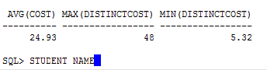

**Practice Problem 2:** Use the COUNT function to count non-NULL values first and then to count the total number of records in one of the tables in JustLee Books Database.

**Helpful Hints:**

|  |  |
| --- | --- |
| **Key Words to Use:** | SELECT, FROM |
| **Tables to Use:** | Any table from the JustLee Books database |
| **Columns to Select:** | Any column having non-null values. |
| **Conditions to Specify:** | Use COUNT function |
| **Suggestions:** | - |

**Expected Output:**

**Note:** records in the output might be in a different order. Following screenshot displays the count of non-null values and total count of records in the customer table.

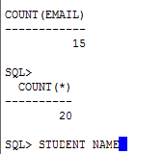

**Practice Problem 3:** Write an SQL query that uses the GROUP BY, WHERE and HAVING statements. Explain what the query is supposed to do.

**Helpful Hints:**

|  |  |
| --- | --- |
| **Key Words to Use:** | SELECT, FROM, WHERE, GROUP BY, HAVING |
| **Tables to Use:** | Any table from the JustLee Books database |
| **Columns to Select:** | Any column |
| **Conditions to Specify:** | - |
| **Suggestions:** | - |

**Expected Output:**

**Note:** records in the output might be in a different order. The following screenshot displays the output of the query-

For each state, count the number of customers having an email and display the result for those states where the number of customers is greater than 2.

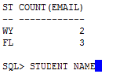

**Practice Problem 4:** Write an SQL query that uses the GROUP BY ROLLUP statement. Explain what the query is supposed to do.

**Helpful Hints:**

|  |  |
| --- | --- |
| **Key Words to Use:** | SELECT, FROM, GROUP BY ROLLUP |
| **Tables to Use:** | Any table from the JustLee Books database |
| **Columns to Select:** | Any column |
| **Conditions to Specify:** | - |
| **Suggestions:** | - |

**Expected Output:**

**Note:** records in the output might be in a different order. The following screenshot displays the result of a query that counts the number of books and the total price in each book or in each order.

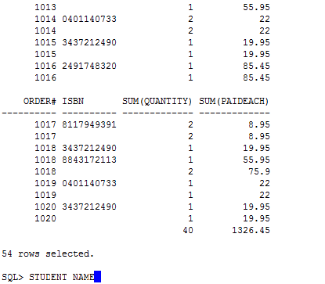

**Practice Problem 5:** Write an SQL query that uses the GROUP BY CUBE statement. Explain what the query is supposed to do.

**Helpful Hints:**

|  |  |
| --- | --- |
| **Key Words to Use:** | SELECT, FROM, GROUP BY CUBE |
| **Tables to Use:** | Any table from the JustLee Books database |
| **Columns to Select:** | Any column |
| **Conditions to Specify:** | - |
| **Suggestions:** | - |

**Expected Output:**

**Note:** records in the output might be in a different order. The following screenshot displays the output of a query that performs aggregations for all possible combinations of the specified columns (name, category, count (title), avg (retail)).

